**ECON300 Fundamentals of Economics**

**Homework 3**

**Note:** Total point is 50.

NAME:______ ________ ID: ___________________

**I. Multiple Choices (2 pts each, 30 pts total)**

1) A monopoly is characterized by all of the following *except*

A) there are only a few sellers each selling a unique product.

B) entry barriers are high.

C) there are no close substitutes to the firm's product.

D) the firm has market power.

2) A firm that has the ability to control to some degree the price of the product it sells

A) is also able to dictate the quantity purchased.

B) faces a demand curve that is inelastic throughout the range of market demand.

C) is a price maker.

D) faces a perfectly inelastic demand curve.

3) Which of the following is a characteristic shared by a perfectly competitive firm and a monopoly?

A) Each must lower its price to sell more output.

B) Each sets a price for its product that will maximize its revenue.

C) Each maximizes profits by producing a quantity for which marginal revenue equals marginal cost.

D) Each maximizes profits by producing a quantity for which price equals marginal cost.

4) A local electricity-generating company has a monopoly that is protected by an entry barrier that takes the form of

A) control of a key raw material.

B) network externalities.

C) economies of scale.

D) perfectly inelastic demand curve.

5) For a natural monopoly to exist

A) a firm must continually buy up its rivals.

B) a firm's long-run average cost curve must exhibit diseconomies of scale beyond the economically efficient output level.

C) a firm's long-run average cost curve must exhibit economies of scale throughout the relevant range of market demand.

D) a firm must have a government-imposed barrier.

6) A monopolist's profit maximizing price and output correspond to the point on a graph

A) where average total cost is minimized.

B) where total costs are the smallest relative to price.

C) where marginal revenue equals marginal cost and charging the price on the market demand curve for that output.

D) where price is as high as possible.

7) If a monopolist's price is $50 per unit and its marginal cost is $25, then

A) to maximize profit the firm should increase output.

B) to maximize profit the firm should decrease output.

C) to maximize profit the firm should continue to produce the output it is producing.

D) Not enough information is given to say what the firm should do to maximize profit.

8) During a business cycle expansion, total production ________ and total employment ________.

A) increases; increases

B) increases; decreases

C) decreases; increases

D) decreases; decreases

9) Macroeconomics, as opposed to microeconomics, includes the study of what determines the level of

A) employment in a specific industry.

B) employment in the economy.

C) output of a specific firm.

D) output of a specific industry.

10) Gross domestic product is calculated by summing up

A) the total quantity of goods and services in the economy.

B) the total quantity of goods and services produced in the economy during a period of time.

C) the total market value of goods and services in the economy.

D) the total market value of final goods and services produced in the economy during a period of time.

11) Which of the following goods is directlycounted in GDP?

A) the lettuce that Subway purchases for its sandwiches

B) the bread that Subway purchases for its sandwiches

C) a 12-inch Subway sandwich purchased by a student

D) the plastic bags that Subway purchases to wrap its sandwiches

***Table 12-2***

|  |  |  |
| --- | --- | --- |
| **Product** | **Quantity** | **Price** |
| Shoes | 40 | $60.00 |
| DVDs | 100 | 18.00 |
| Tomatoes | 2,000 | 1.00 |
| Ketchup | 300 | 4.00 |

12) ***Refer to Table 12-2.*** Suppose that a simple economy produces only four goods and services: shoes, DVDs, tomatoes, and ketchup. Assume one half of the tomatoes are used in making the ketchup and the other half of the tomatoes are purchased by households. Using the information in the above table, nominal GDP for this simple economy equals

A) $7,400.

B) $6,400.

C) $5,800.

D) 2,440 units.

13) If the number employed is 190 million, the working-age population is 230 million, and the number unemployed is 10 million, then the unemployment rate is

A) 5%.

B) 5.2%.

C) 8%.

D) 10%.

14) The nominal GDP of the U.S. in 2012 was approximately $16.2 trillion. This means that

A) the value of output in 2012 was around $16.2 trillion.

B) total income in 2012 was around $16.2 trillion.

C) total spending in 2012 was around $16.2 trillion.

D) all of the above are true.

15) The purchase of a new automobile is included in

A) consumption expenditures on services.

B) consumption expenditures on nondurable goods

C) consumption expenditures on durable goods.

D) investment expenditures.

**II. Essays**

***Figure 10-2***

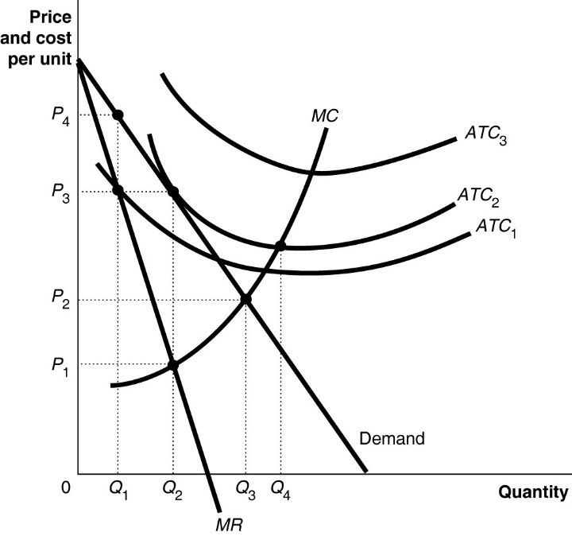

Figure 10-2 above shows the demand and cost curves facing a monopolist. (3 pts each,15 pts total)

1) ***Refer to Figure 10-2***. To maximize profit, the firm will produce which quantity?

- Q2

2) ***Refer to Figure 10-2.*** The firm's profit-maximizing price is which one?   
  
 - P3

3) ***Refer to Figure 10-2.*** If the firm's average total cost curve is *ATC*1, the firm will suffer a loss, break even or make a profit?   
  
 - Make a profit

4) ***Refer to Figure 10-2.*** If the firm's average total cost curve is *ATC*2, the firm will suffer a loss, break even or make a profit?   
  
 - Break even

5) ***Refer to Figure 10-2.*** If the firm's average total cost curve is *ATC*3, the firm will suffer a loss, break even or make a profit?   
  
 - Suffer a loss

***Table 12-8***

|  |  |  |
| --- | --- | --- |
| **Product** | **Quantity** | **Price** |
| Sweaters | 50 | $50.00 |
| CDs | 150 | 10.00 |
| Sugar | 600 | 1.00 |
| Soft drinks | 800 | 0.75 |

6) ***Refer to Table 12-8.*** Suppose that a simple economy produces only four goods and services: sweaters, CDs, sugar, and soft drinks. Assume one half of the sugar is used in making the soft drinks and the other half of the sugar is purchased by households. Calculate nominal GDP for this simple economy. (3 pts)

- $4900

7) If the number of unemployed workers is 19 million, the number in the working-age population is 500 million, and the unemployment rate is 4%, what is the labor force participation rate? (2 pts)

- 95%